Assignment 4 K-means for clustering

Avinash Ravipudi

2022-11-04

#install.packages("httr")  
#install.packages("readr")  
#install.packages("factoextra")  
#install.packages("flexclust")  
library(httr)  
library(readr)  
library(tidyverse)

## ── Attaching packages ─────────────────────────────────────── tidyverse 1.3.2 ──  
## ✔ ggplot2 3.3.6 ✔ dplyr 1.0.10  
## ✔ tibble 3.1.8 ✔ stringr 1.4.1   
## ✔ tidyr 1.2.0 ✔ forcats 0.5.2   
## ✔ purrr 0.3.4   
## ── Conflicts ────────────────────────────────────────── tidyverse_conflicts() ──  
## ✖ dplyr::filter() masks stats::filter()  
## ✖ dplyr::lag() masks stats::lag()

library(factoextra)

## Welcome! Want to learn more? See two factoextra-related books at https://goo.gl/ve3WBa

library(ISLR)  
library(flexclust)

## Loading required package: grid  
## Loading required package: lattice  
## Loading required package: modeltools  
## Loading required package: stats4

library(caret)

##   
## Attaching package: 'caret'  
##   
## The following object is masked from 'package:purrr':  
##   
## lift  
##   
## The following object is masked from 'package:httr':  
##   
## progress

#Importing Data set

#importing Data set and converting   
getwd()

## [1] "/Users/avinashravipudi/Documents/FML/Assignment - 4 "

pharma<-read.csv("Pharmaceuticals.csv")  
#summarize the Data  
#str(pharma)  
head(pharma,10)

## Symbol Name Market_Cap Beta PE_Ratio ROE ROA  
## 1 ABT Abbott Laboratories 68.44 0.32 24.7 26.4 11.8  
## 2 AGN Allergan, Inc. 7.58 0.41 82.5 12.9 5.5  
## 3 AHM Amersham plc 6.30 0.46 20.7 14.9 7.8  
## 4 AZN AstraZeneca PLC 67.63 0.52 21.5 27.4 15.4  
## 5 AVE Aventis 47.16 0.32 20.1 21.8 7.5  
## 6 BAY Bayer AG 16.90 1.11 27.9 3.9 1.4  
## 7 BMY Bristol-Myers Squibb Company 51.33 0.50 13.9 34.8 15.1  
## 8 CHTT Chattem, Inc 0.41 0.85 26.0 24.1 4.3  
## 9 ELN Elan Corporation, plc 0.78 1.08 3.6 15.1 5.1  
## 10 LLY Eli Lilly and Company 73.84 0.18 27.9 31.0 13.5  
## Asset_Turnover Leverage Rev_Growth Net_Profit_Margin Median_Recommendation  
## 1 0.7 0.42 7.54 16.1 Moderate Buy  
## 2 0.9 0.60 9.16 5.5 Moderate Buy  
## 3 0.9 0.27 7.05 11.2 Strong Buy  
## 4 0.9 0.00 15.00 18.0 Moderate Sell  
## 5 0.6 0.34 26.81 12.9 Moderate Buy  
## 6 0.6 0.00 -3.17 2.6 Hold  
## 7 0.9 0.57 2.70 20.6 Moderate Sell  
## 8 0.6 3.51 6.38 7.5 Moderate Buy  
## 9 0.3 1.07 34.21 13.3 Moderate Sell  
## 10 0.6 0.53 6.21 23.4 Hold  
## Location Exchange  
## 1 US NYSE  
## 2 CANADA NYSE  
## 3 UK NYSE  
## 4 UK NYSE  
## 5 FRANCE NYSE  
## 6 GERMANY NYSE  
## 7 US NYSE  
## 8 US NASDAQ  
## 9 IRELAND NYSE  
## 10 US NYSE

set.seed(23)  
#Data frame Z Score scaling  
pharma_scaled <- scale(pharma[,3:11])  
summary(pharma_scaled)

## Market_Cap Beta PE_Ratio ROE   
## Min. :-0.9768 Min. :-1.3466 Min. :-1.3404 Min. :-1.4515   
## 1st Qu.:-0.8763 1st Qu.:-0.6844 1st Qu.:-0.4023 1st Qu.:-0.7223   
## Median :-0.1614 Median :-0.2560 Median :-0.2429 Median :-0.2118   
## Mean : 0.0000 Mean : 0.0000 Mean : 0.0000 Mean : 0.0000   
## 3rd Qu.: 0.2762 3rd Qu.: 0.4841 3rd Qu.: 0.1495 3rd Qu.: 0.3450   
## Max. : 2.4200 Max. : 2.2758 Max. : 3.4971 Max. : 2.4597   
## ROA Asset_Turnover Leverage Rev_Growth   
## Min. :-1.7128 Min. :-1.8451 Min. :-0.74966 Min. :-1.4971   
## 1st Qu.:-0.9047 1st Qu.:-0.4613 1st Qu.:-0.54487 1st Qu.:-0.6328   
## Median : 0.1289 Median :-0.4613 Median :-0.31449 Median :-0.3621   
## Mean : 0.0000 Mean : 0.0000 Mean : 0.00000 Mean : 0.0000   
## 3rd Qu.: 0.8430 3rd Qu.: 0.9225 3rd Qu.: 0.01828 3rd Qu.: 0.7693   
## Max. : 1.8389 Max. : 1.8451 Max. : 3.74280 Max. : 1.8862   
## Net_Profit_Margin   
## Min. :-1.99560   
## 1st Qu.:-0.68504   
## Median : 0.06168   
## Mean : 0.00000   
## 3rd Qu.: 0.82364   
## Max. : 1.49416

# Data Frame Range Scaling   
pharma_range <- scale(pharma[,3:11])

The k-means algorithm was used to divide the 21 enterprises into three groups with no variable weights. We chose k=3 since that is the optimal k indicated by the silhouette approach.

set.seed(23)  
dst_rows <- get_dist(pharma_scaled)  
fviz_dist(dst_rows) #To visualize distance between matrix rows

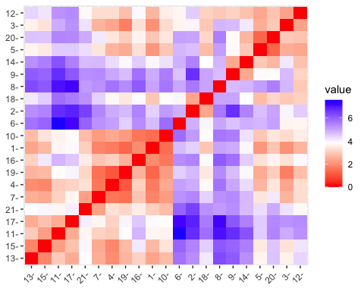

cluster1 <- kmeans(pharma_scaled, centers = 3, nstart = 15) # HEre taking K=3 & nstart=15  
fviz_cluster(cluster1, data = pharma_scaled)

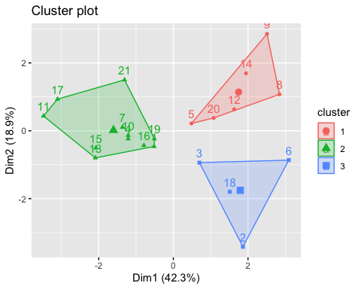

print(cluster1)

## K-means clustering with 3 clusters of sizes 6, 11, 4  
##   
## Cluster means:  
## Market_Cap Beta PE_Ratio ROE ROA Asset_Turnover  
## 1 -0.8261772 0.4775991 -0.3696184 -0.5631589 -0.8514589 -0.9994088  
## 2 0.6733825 -0.3586419 -0.2763512 0.6565978 0.8344159 0.4612656  
## 3 -0.6125361 0.2698666 1.3143935 -0.9609057 -1.0174553 0.2306328  
## Leverage Rev_Growth Net_Profit_Margin  
## 1 0.8502201 0.9158889 -0.3319956  
## 2 -0.3331068 -0.2902163 0.6823310  
## 3 -0.3592866 -0.5757385 -1.3784169  
##   
## Clustering vector:  
## [1] 2 3 3 2 1 3 2 1 1 2 2 1 2 1 2 2 2 3 2 1 2  
##   
## Within cluster sum of squares by cluster:  
## [1] 32.14336 43.30886 20.54199  
## (between_SS / total_SS = 46.7 %)  
##   
## Available components:  
##   
## [1] "cluster" "centers" "totss" "withinss" "tot.withinss"  
## [6] "betweenss" "size" "iter" "ifault"

fviz_nbclust(pharma_scaled, kmeans, method = "wss") # WSS method (ELBOW METHOOD)

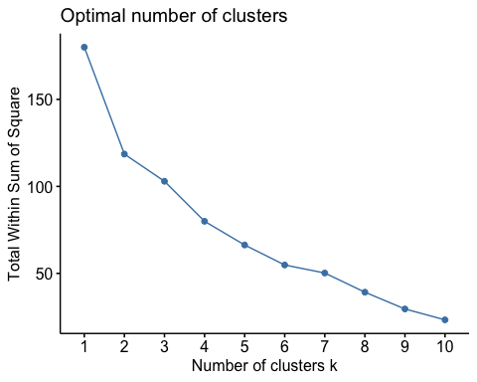

fviz_nbclust(pharma_scaled, kmeans, method = "silhouette") #SILHOUETTE Methood (To find best K value)

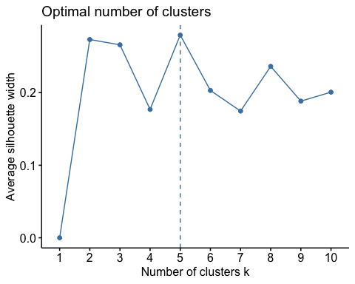 I did not use the WSS approach since the graph did not show a distinct elbow and was extremely unclear. The graph does not indicate the elbow/knee position, and it flattens out more than once at k = 4 and 6, respectively, and I chose the silhouette approach since it is apparent to display the ideal cluster K = 5.

#let's look at the mean value from actual data by clusters  
aggregate(pharma[3:11], by=list(cluster=cluster1$cluster), mean)

## cluster Market_Cap Beta PE_Ratio ROE ROA Asset_Turnover Leverage  
## 1 1 9.23500 0.6483333 19.43333 17.3 5.983333 0.4833333 1.2500000  
## 2 2 97.11364 0.4336364 20.95455 35.7 14.954545 0.8000000 0.3254545  
## 3 3 21.75500 0.5950000 46.90000 11.3 5.100000 0.7500000 0.3050000  
## Rev_Growth Net_Profit_Margin  
## 1 23.49000 13.51667  
## 2 10.16455 20.17273  
## 3 7.01000 6.65000

actual_data <- cbind(pharma, cluster = cluster1$cluster)  
tibble(actual_data)

## # A tibble: 21 × 15  
## Symbol Name Marke…¹ Beta PE_Ra…² ROE ROA Asset…³ Lever…⁴ Rev_G…⁵  
## <chr> <chr> <dbl> <dbl> <dbl> <dbl> <dbl> <dbl> <dbl> <dbl>  
## 1 ABT Abbott Labo… 68.4 0.32 24.7 26.4 11.8 0.7 0.42 7.54  
## 2 AGN Allergan, I… 7.58 0.41 82.5 12.9 5.5 0.9 0.6 9.16  
## 3 AHM Amersham plc 6.3 0.46 20.7 14.9 7.8 0.9 0.27 7.05  
## 4 AZN AstraZeneca… 67.6 0.52 21.5 27.4 15.4 0.9 0 15   
## 5 AVE Aventis 47.2 0.32 20.1 21.8 7.5 0.6 0.34 26.8   
## 6 BAY Bayer AG 16.9 1.11 27.9 3.9 1.4 0.6 0 -3.17  
## 7 BMY Bristol-Mye… 51.3 0.5 13.9 34.8 15.1 0.9 0.57 2.7   
## 8 CHTT Chattem, Inc 0.41 0.85 26 24.1 4.3 0.6 3.51 6.38  
## 9 ELN Elan Corpor… 0.78 1.08 3.6 15.1 5.1 0.3 1.07 34.2   
## 10 LLY Eli Lilly a… 73.8 0.18 27.9 31 13.5 0.6 0.53 6.21  
## # … with 11 more rows, 5 more variables: Net_Profit_Margin <dbl>,  
## # Median_Recommendation <chr>, Location <chr>, Exchange <chr>, cluster <int>,  
## # and abbreviated variable names ¹​Market_Cap, ²​PE_Ratio, ³​Asset_Turnover,  
## # ⁴​Leverage, ⁵​Rev_Growth

by(actual_data, factor(actual_data$cluster), summary)#intensive statistical cluster analysis

## factor(actual_data$cluster): 1  
## Symbol Name Market_Cap Beta   
## Length:6 Length:6 Min. : 0.410 Min. :0.2400   
## Class :character Class :character 1st Qu.: 0.885 1st Qu.:0.4025   
## Mode :character Mode :character Median : 1.900 Median :0.7000   
## Mean : 9.235 Mean :0.6483   
## 3rd Qu.: 3.095 3rd Qu.:0.8250   
## Max. :47.160 Max. :1.0800   
## PE_Ratio ROE ROA Asset_Turnover   
## Min. : 3.60 Min. :10.20 Min. :4.300 Min. :0.3000   
## 1st Qu.:18.77 1st Qu.:12.18 1st Qu.:5.175 1st Qu.:0.3500   
## Median :20.00 Median :18.25 Median :6.100 Median :0.5500   
## Mean :19.43 Mean :17.30 Mean :5.983 Mean :0.4833   
## 3rd Qu.:24.52 3rd Qu.:21.70 3rd Qu.:6.800 3rd Qu.:0.6000   
## Max. :28.60 Max. :24.10 Max. :7.500 Max. :0.6000   
## Leverage Rev_Growth Net_Profit_Margin Median_Recommendation  
## Min. :0.2000 Min. : 6.38 Min. : 7.50 Length:6   
## 1st Qu.:0.4875 1st Qu.:17.20 1st Qu.:11.47 Class :character   
## Median :1.0000 Median :28.00 Median :13.10 Mode :character   
## Mean :1.2500 Mean :23.49 Mean :13.52   
## 3rd Qu.:1.3550 3rd Qu.:30.07 3rd Qu.:14.65   
## Max. :3.5100 Max. :34.21 Max. :21.30   
## Location Exchange cluster   
## Length:6 Length:6 Min. :1   
## Class :character Class :character 1st Qu.:1   
## Mode :character Mode :character Median :1   
## Mean :1   
## 3rd Qu.:1   
## Max. :1   
## ------------------------------------------------------------   
## factor(actual_data$cluster): 2  
## Symbol Name Market_Cap Beta   
## Length:11 Length:11 Min. : 34.10 Min. :0.1800   
## Class :character Class :character 1st Qu.: 59.48 1st Qu.:0.3350   
## Mode :character Mode :character Median : 73.84 Median :0.4600   
## Mean : 97.11 Mean :0.4336   
## 3rd Qu.:127.33 3rd Qu.:0.5150   
## Max. :199.47 Max. :0.6500   
## PE_Ratio ROE ROA Asset_Turnover Leverage   
## Min. :13.10 Min. :17.9 Min. :11.20 Min. :0.50 Min. :0.0000   
## 1st Qu.:18.45 1st Qu.:26.9 1st Qu.:13.35 1st Qu.:0.65 1st Qu.:0.0800   
## Median :21.50 Median :31.0 Median :15.00 Median :0.80 Median :0.2800   
## Mean :20.95 Mean :35.7 Mean :14.95 Mean :0.80 Mean :0.3255   
## 3rd Qu.:24.15 3rd Qu.:43.1 3rd Qu.:15.85 3rd Qu.:0.90 3rd Qu.:0.4750   
## Max. :28.40 Max. :62.9 Max. :20.30 Max. :1.10 Max. :1.1200   
## Rev_Growth Net_Profit_Margin Median_Recommendation Location   
## Min. :-2.690 Min. :14.10 Length:11 Length:11   
## 1st Qu.: 4.455 1st Qu.:17.75 Class :character Class :character   
## Median : 8.560 Median :20.60 Mode :character Mode :character   
## Mean :10.165 Mean :20.17   
## 3rd Qu.:16.175 3rd Qu.:22.90   
## Max. :25.540 Max. :25.50   
## Exchange cluster   
## Length:11 Min. :2   
## Class :character 1st Qu.:2   
## Mode :character Median :2   
## Mean :2   
## 3rd Qu.:2   
## Max. :2   
## ------------------------------------------------------------   
## factor(actual_data$cluster): 3  
## Symbol Name Market_Cap Beta   
## Length:4 Length:4 Min. : 6.30 Min. :0.4000   
## Class :character Class :character 1st Qu.: 7.26 1st Qu.:0.4075   
## Mode :character Mode :character Median :12.24 Median :0.4350   
## Mean :21.75 Mean :0.5950   
## 3rd Qu.:26.73 3rd Qu.:0.6225   
## Max. :56.24 Max. :1.1100   
## PE_Ratio ROE ROA Asset_Turnover Leverage   
## Min. :20.7 Min. : 3.90 Min. :1.400 Min. :0.60 Min. :0.0000   
## 1st Qu.:26.1 1st Qu.:10.65 1st Qu.:4.475 1st Qu.:0.60 1st Qu.:0.2025   
## Median :42.2 Median :13.20 Median :5.600 Median :0.75 Median :0.3100   
## Mean :46.9 Mean :11.30 Mean :5.100 Mean :0.75 Mean :0.3050   
## 3rd Qu.:63.0 3rd Qu.:13.85 3rd Qu.:6.225 3rd Qu.:0.90 3rd Qu.:0.4125   
## Max. :82.5 Max. :14.90 Max. :7.800 Max. :0.90 Max. :0.6000   
## Rev_Growth Net_Profit_Margin Median_Recommendation Location   
## Min. :-3.170 Min. : 2.600 Length:4 Length:4   
## 1st Qu.: 4.495 1st Qu.: 4.775 Class :character Class :character   
## Median : 8.105 Median : 6.400 Mode :character Mode :character   
## Mean : 7.010 Mean : 6.650   
## 3rd Qu.:10.620 3rd Qu.: 8.275   
## Max. :15.000 Max. :11.200   
## Exchange cluster   
## Length:4 Min. :3   
## Class :character 1st Qu.:3   
## Mode :character Median :3   
## Mean :3   
## 3rd Qu.:3   
## Max. :3

Recommendations, Location and Exchange of cluster

#Cluster median recommendation  
T_Recom <- table(actual_data$cluster, actual_data$Median_Recommendation)   
names(dimnames(T_Recom)) <- c("Cluster", "Recommendation")  
TR <- addmargins(T_Recom)  
TR

## Recommendation  
## Cluster Hold Moderate Buy Moderate Sell Strong Buy Sum  
## 1 1 3 2 0 6  
## 2 6 3 2 0 11  
## 3 2 1 0 1 4  
## Sum 9 7 4 1 21

The data do not show a clear link between clusterMedian Recommendation. There are 21 recommendations in total, with 1 strong buy, 7 moderate buys, 9 holds, and 4 moderate sells.

#Cluster-based location breakdown  
T_Location <- table(actual_data$cluster, actual_data$Location)  
names(dimnames(T_Location)) <- c("Cluster", "Location")  
Tlocation <- addmargins(T_Location)  
Tlocation

## Location  
## Cluster CANADA FRANCE GERMANY IRELAND SWITZERLAND UK US Sum  
## 1 0 1 0 1 0 0 4 6  
## 2 0 0 0 0 1 2 8 11  
## 3 1 0 1 0 0 1 1 4  
## Sum 1 1 1 1 1 3 13 21

We cannot deduce any association between cluster Location from the findings. A total of 21 firms are divided into 13 in the United States, three in the United Kingdom, and one each in Canada, France, Germany, Ireland, and Switzerland.

#Exchange breakdown by cluster  
T_Exchange <- table(actual_data$cluster, actual_data$Exchange)  
names(dimnames(T_Exchange)) <- c("Cluster", "Exchange")  
Texchange <- addmargins(T_Exchange)  
Texchange

## Exchange  
## Cluster AMEX NASDAQ NYSE Sum  
## 1 1 1 4 6  
## 2 0 0 11 11  
## 3 0 0 4 4  
## Sum 1 1 19 21

The results show that there is no link between clusterExchange. There are 21 corporations in all, divided into 1 Amex, 1 Nasdaq, and 19 NYSE.

Investigating the options

fviz_nbclust(pharma_range, FUN = kmeans, method = "silhouette")



fviz_nbclust(pharma_range, kmeans, method = "wss")

 We also perform tests to determine the best k using range normalization. The ideal k is 2 from the silhouette and 6 from the elbow (not clear). We’ll stick with z-score normalization data because the k from range normalization isn’t as good.`

set.seed(11)  
cluster2 = kcca(pharma_scaled, k=3, kccaFamily("kmeans"))  
cluster2

## kcca object of family 'kmeans'   
##   
## call:  
## kcca(x = pharma_scaled, k = 3, family = kccaFamily("kmeans"))  
##   
## cluster sizes:  
##   
## 1 2 3   
## 4 13 4

clusters(cluster2)

## [1] 2 1 2 2 2 1 2 1 2 2 3 2 3 2 3 2 3 1 2 2 2

#Apply the predict() function  
clusters_index <- predict(cluster2)  
image(cluster2)  
points(pharma_scaled, col=clusters_index, pch=17, cex=1.0)

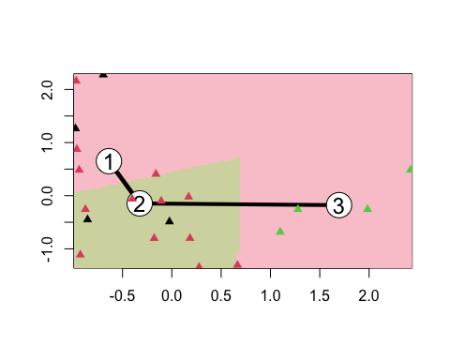 To run kmeans cluster on k =3, we use the kcca algorithm instead of kmeans from basic R.

set.seed(11)  
cluster2 = kcca(pharma_scaled, k=3, kccaFamily("kmedians"))  
cluster2

## kcca object of family 'kmedians'   
##   
## call:  
## kcca(x = pharma_scaled, k = 3, family = kccaFamily("kmedians"))  
##   
## cluster sizes:  
##   
## 1 2 3   
## 9 8 4

clusters(cluster2)

## [1] 2 1 1 2 2 1 2 1 1 2 3 1 3 1 3 2 3 1 2 1 2

#Apply the predict() function  
clusters_index <- predict(cluster2)  
image(cluster2)  
points(pharma_scaled, col=clusters_index, pch=16, cex=1.0)

